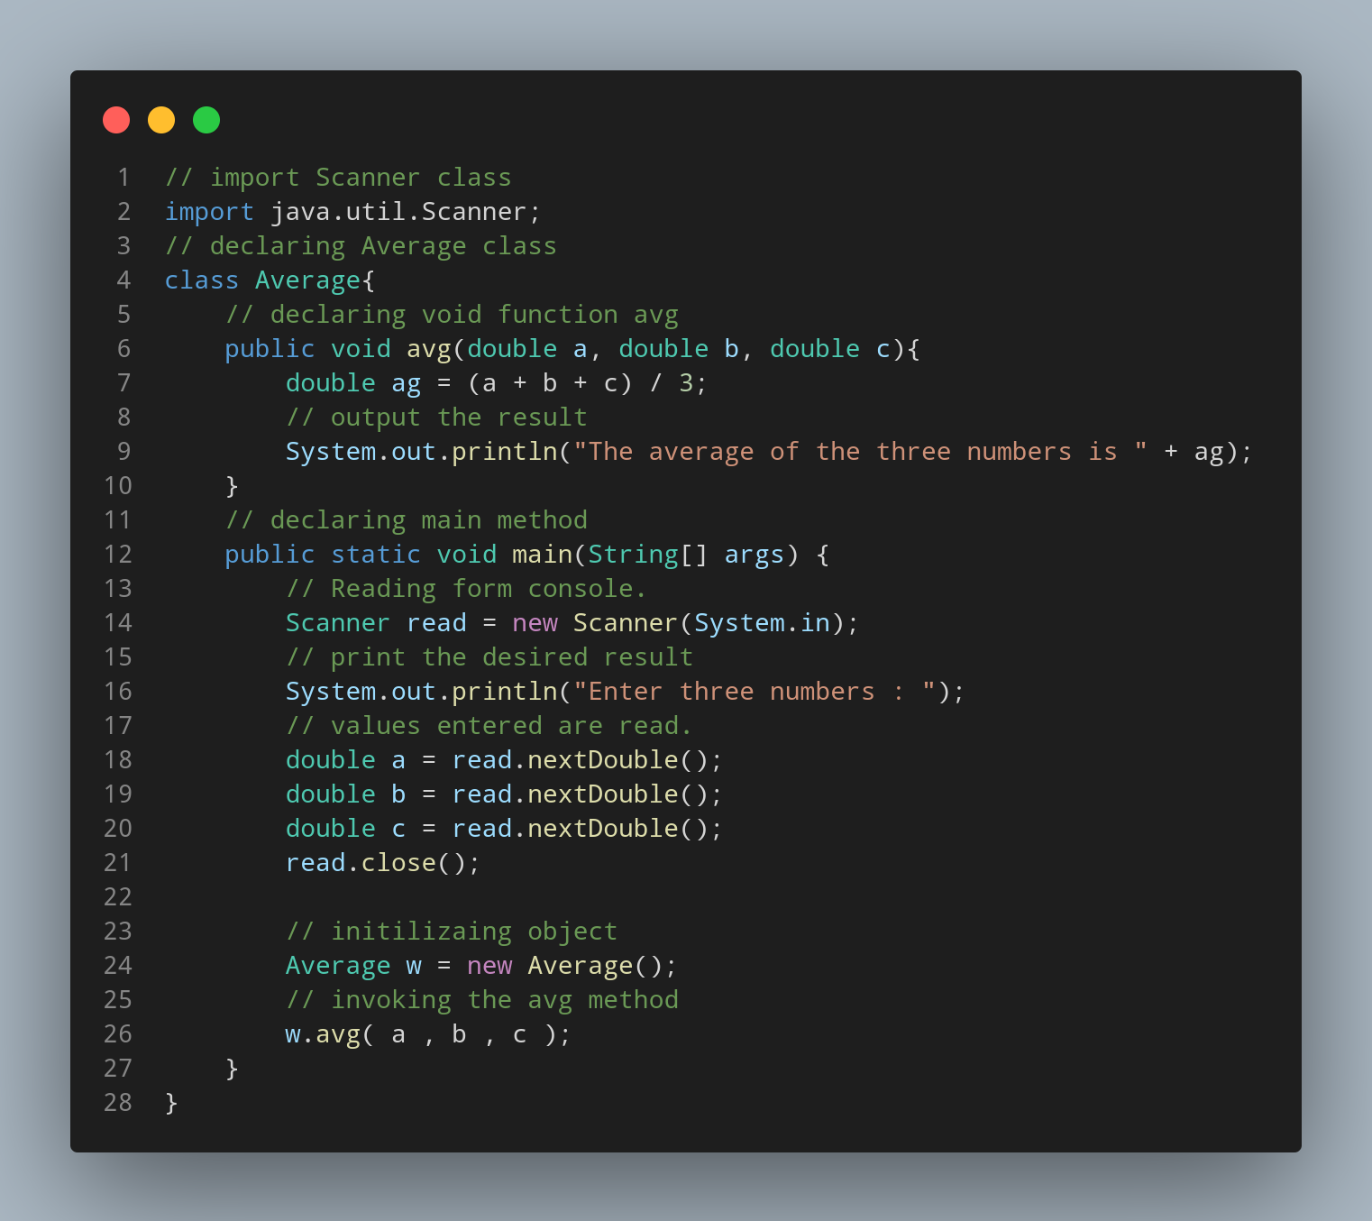

#Doc
java.util.Scanner is imported.
Average is declared as class.
avg method is declared.
Variable ag of double data type is declared.
Code to print the result is written.
Main method is declared.
Code to read the datas entered from console is written.
Code to print the required output is written.
Code to read and assign variables to the entered data are written.
Object is initialized.
avg method is invoked.

